Random Verse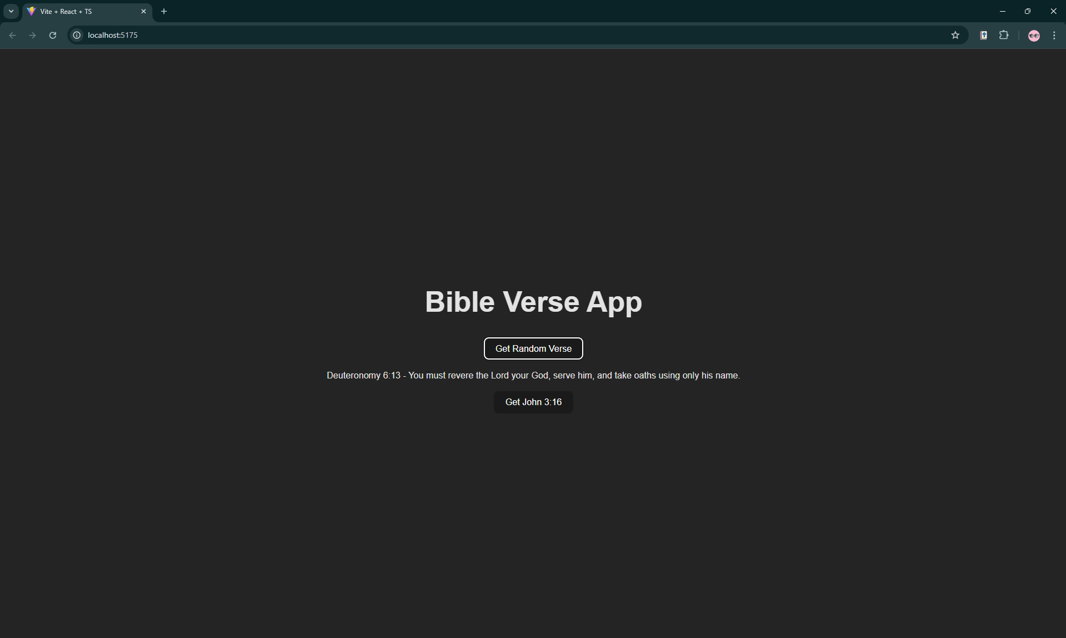

Specific Verse

